

**Goldfields Kindergarten Newsletter**

**Here-turi-Kōkā/Mahuru (August/ September) 2014**

**Tena koe, Hello, Guten Tag**



**The South Otago Schools and Centres Kaupapa Māori Festival/Hui Ako**

In July we took the older children down to Balclutha to perform at the Hui Ako. This was only made possible through the magnificent support of our community. A huge thank you to Natasha Hughes for giving up her time and knowledge to teach the children our Waiata. Claire Anderson for volunteering her time to drive the bus and finally the Tuakpeka West Trust for kindly donating the use of the bus and petrol. Wow!!

The children did us proud getting up on stage performing like masters. We are already looking forward to our performance next year

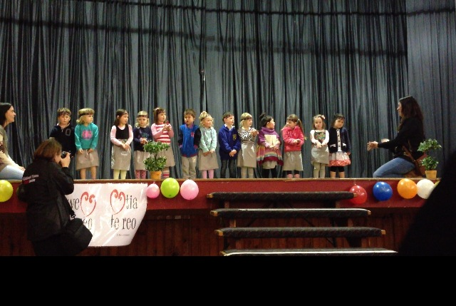

**A Dress Up Day**

Theme: What I want to be when I grow up.

When: 23rd September 2014

This Term we are learning about being responsible, one of the tools we have used to empower the children has been looking up to their role models. To celebrate this we throught it would be great to have a dress up day with the theme What I want to be when I grow up as often these people/things are role models for our children.

**House-Keeping**

**☺** The Teachers are now having a meeting every morning from 8-9am if you are at kindergarten early please feel free to come in and settle your child before the teachers come out of their meeting at 9.00am

**☺** If your child is going to be away for a day (be that through holiday or illness), please let the kindergarten know ASAP either ring or text. Thank you.

**☺** Could everyone please bring in a box of tissues our supplies are low and it is time to restock

**☺** End of term tidy up i sfrom 22nd-26th of September. Many hands make light work, we would appreciate a hour of your time that week to help.

**☺** Please ensure all of your childs clothes is labelled this is really important as it starts to warm up and children are wearing lots of layers

**Term dates**

Term 3 finishes Friday the 26th of September, Goldfields Kindergarten will be **closed from the 27th of September until the 5th of October 2014** reopening Monday the 6th of October

**Welcomes & Farewells**

Best wishes to Oscar, Micheal and Beth as they all head off to School. We would also like to wish Mia, Apihai, Parekura and Ajay As the continue there learning journeys in other places.

Welcome to Te Manawa and Ava

of July

2015

Yes it is that time to start thinking about next year and your childs bookings . We are currently operating a waiting list, so if you are intending on changing your hours, email - [goldfields@sokindergartens.org.nz](mailto:goldfields@sokindergartens.org.nz) or txt - **0212420429** so we can put you on the waiting list and can hopefully accommodate your needs as soon as possible.

**Learning And Development**

**Responsibility**

This term we are learning about responsibility. As a team we are providing consistant extectation on children to follow the routines and regular events of the day and supporting older children to role model being responsible to our their younger friends.

**Self Review**

Currently the team are working on a self review on “How effectively are teachers empowering the children to be engaged within the programme?” This has lead the teachers on a journey of how we currently work and what best practice looks like. We are now reflecting on how this will look for our centre. We are considering how the centre is structured and how we can best utilise the teachers different strengths. As we work through this process we will continue to inform you of the changes we will be making, it is all very exciting

**New Resources**

Thanks to the on going hard work of the fundraising committee the children and teachers have been very excited to get some new resources. The new bookshelf, puzzle shelf and music shelf have made the resources more accessible to the children supporting our current learning goal of responsibility. We have also been able to purchase a water trough, new books and puzzles for the younger children, dolls clothes, office chairs, mobile, a mirror, washing line and ironing board as well asa new change table and nappy bucket for the nappy room. Wow!!

**Fundraising**

We made $299 cake stall held outside the four square. Thank you to all the Whanau that baked to make this bake sale such a success. A special thank you to Jaimee and Sarah who gave up there time to man t he bake sale also to Sandra who donated a jug which we raffled off and won by Mrs S Young.

Due to its success we have decided to have another Bake Stall on the 19th of September. This time we are also going to do a raffle as it was so popular last time. Please bring along some baking and something non persible for the raffle. Thank you

We also ran a successful fundraiser by doing the canteen at the rugby final. This made $307.40. A huge thank you to Sarah, Jaimee, Amelia and Melissa for making this possible.

The next fundraising meeting will be held on the 18th of September at 7pm , all welcome

**Annual Plan Update**

Community –*To involve our parents in what we do within our kindergarten to support their child/children’s learning focusing on Group planning.*

Have you seen the speech bubbles on our programme planning walls? Feel free to write in them how you see your child being responsible at home.

Have Your Details Changed?

Please see a teacher with any of the following changes:

* Updating your childs immunisations information
* Address
* Phone Number
* Email Address
* Allergies

Thank you

**Ka kite ano Emma, Melissa, Fiona &Jemma**



**Lunch Box Muesli Slice**

## What you will need

• 30ml (2 Tbsp) soya oil • 60g (1/4 cup) sugar • 10g (1 tsp) golden syrup • 1 egg

• 90ml water • 70g weetbix • 65g (1/2 cup) dried dates, chopped

• 65g (1/2 cup) dried apricots, chopped • 55g brazil nuts, chopped

• 1g (1/2 tsp) ground cinnamon • 25g (1/4 cup) shredded coconut

• 65g (1/2 cup) jumbo rolled oats • 165g (1 3/4 cups) wholemeal flour

• 4g (1 tsp) baking powder • 30g icing sugar • 15ml lemon juice

Bottom of Form

**Muesli slice**

1. Mix together the oil, sugar, golden syrup, egg, and water and set aside
2. Mix together the Weetbix, dried dates, dried apricots, brazil nuts, cinnamon, coconut, rolled oats, flour and baking powder
3. Mix wet mixture into dry ingredients
4. Press into a slice tin and bake at 180C for 30 minutes.
5. Allow to cool

**Icing**

1. Mix the icing sugar with the lemon juice
2. In a small piping bag (folded out of a piece of greaseproof paper) pipe lines across the slice at approximately 1cm intervals before it has been cut.